MLOps Assignment 2
Fine-Tuning DistilBERT for Goodreads Genre Classification

Field | Value
Student Name | Alok Sahni
Roll Number | G25AIT2138
Programme | PGD AI
Institute | IIT Jodhpur
Training Platform | Kaggle Notebook (NVIDIA Tesla T4 GPU)
Submission Type | Individual Assignment

Submission Resources
Resource | Link
GitHub Repository | https://github.com/g25ait2138-collab/distilbert-goodreads-genres
Kaggle Notebook | https://www.kaggle.com/code/aloksahnig25ait2138/notebook8d09f3f76d/script
Hugging Face Model | https://huggingface.co/ALOK2026/distilbert-goodreads-genres
W&B Dashboard | https://wandb.ai/g25ait2138-iitj/mlops-assignment2/workspace?nw=nwuserg25ait2138

1. Project Overview
This assignment implements a complete end-to-end MLOps workflow for transformer-based Natural Language Processing using the UCSD Goodreads review dataset. The objective is to fine-tune DistilBERT for multi-class genre classification across eight literary genres while demonstrating production-oriented practices: modular code organisation, secure credential handling through Kaggle Secrets, live experiment monitoring with Weights & Biases, artifact versioning, cloud-based GPU training, and public model deployment to the Hugging Face Hub.
The starter Colab notebook was reorganised into four modular Python scripts (data.py, train.py, eval.py, utils.py) and executed inside a Kaggle Notebook with GPU acceleration. Every training run is fully reproducible: hyperparameters, metrics, system telemetry, and the final classification report are tracked on W&B, and the fine-tuned model is publicly downloadable from Hugging Face.

2. Model Selection Rationale
The selected model is distilbert-base-cased, a lightweight distilled version of BERT developed by Hugging Face. DistilBERT retains approximately 97% of BERT's language-understanding capability while being roughly 40% smaller and 60% faster, which is decisive given the constraints of the free Kaggle Tesla T4 GPU. The cased variant was chosen because Goodreads reviews contain proper nouns, book titles, and author names where capitalisation carries meaningful semantic signal that the uncased variant would discard. Practically, DistilBERT also enables a longer maximum sequence length (512 tokens) and a reasonable batch size (16) on a single T4. Finally, DistilBERT integrates cleanly with the Hugging Face Trainer API, AutoTokenizer, and the Hub, making the post-training deployment step a single function call.

3. Kaggle Training Setup
Training was performed on a Kaggle Notebook with GPU acceleration enabled under Settings → Accelerator → GPU T4. The Internet toggle was switched on so the notebook could download the UCSD dataset, install Python packages, and push the trained model to the Hugging Face Hub. API tokens were stored as Kaggle Secrets (Add-ons → Secrets) and loaded at runtime via kaggle_secrets.UserSecretsClient, so they never appear in the notebook source.

Kaggle Environment
Component | Value
Platform | Kaggle Notebook
GPU | NVIDIA Tesla T4 (free tier, ~30 hr/week)
Framework | PyTorch + Hugging Face Transformers
Python Version | 3.10+
Secrets | WANDB_API_KEY, HF_TOKEN (via Kaggle Secrets)

Hyperparameters
Hyperparameter | Value
Epochs | 3
Learning Rate | 3e-5
Train Batch Size | 16
Eval Batch Size | 32
Max Sequence Length | 512
Warmup Steps | 100
Weight Decay | 0.01
Optimizer | AdamW
Best-Model Strategy | load_best_model_at_end (lowest val loss)

4. Dataset and Pipeline
The UCSD Goodreads 'by genre' review dumps were streamed directly from the McAuley Lab CDN. Eight genres were used: poetry, children, comics_graphic, fantasy_paranormal, history_biography, mystery_thriller_crime, romance, and young_adult. For each genre, ~1,000 reviews were sampled and split 800/200 into train/test, giving 6,400 train and 1,600 test reviews. Reviews were tokenised with DistilBertTokenizerFast (truncation=True, padding=True, max_length=512) and label-encoded deterministically (sorted) so the integer-to-genre mapping is reproducible across runs.

5. Training and W&B Tracking
Fine-tuning was driven by the Hugging Face Trainer with report_to="wandb", which enables automatic logging of training loss, validation loss, accuracy, weighted F1, learning-rate schedule, gradient norms, and GPU utilisation. The W&B run was initialised with a single wandb.init() call recording the full hyperparameter configuration so every run is reproducible from the dashboard.

Per-Epoch Training Progress
Epoch | Train Loss | Val Loss | Accuracy | F1 | Precision | Recall
1 | 1.0665 | 2.8248 | 0.5619 | 0.5673 | 0.5781 | 0.5619
2 | 0.9481 | 3.0193 | 0.5625 | 0.5674 | 0.5792 | 0.5625
3 | 0.5708 | 3.1652 | 0.5713 | 0.5747 | 0.5792 | 0.5713
Training loss decreased steadily across epochs. Validation loss bottomed out at epoch 1 and rose afterwards, so load_best_model_at_end automatically restored the epoch-1 checkpoint as the final model.

A Screenshot of W & B Training Dashboard

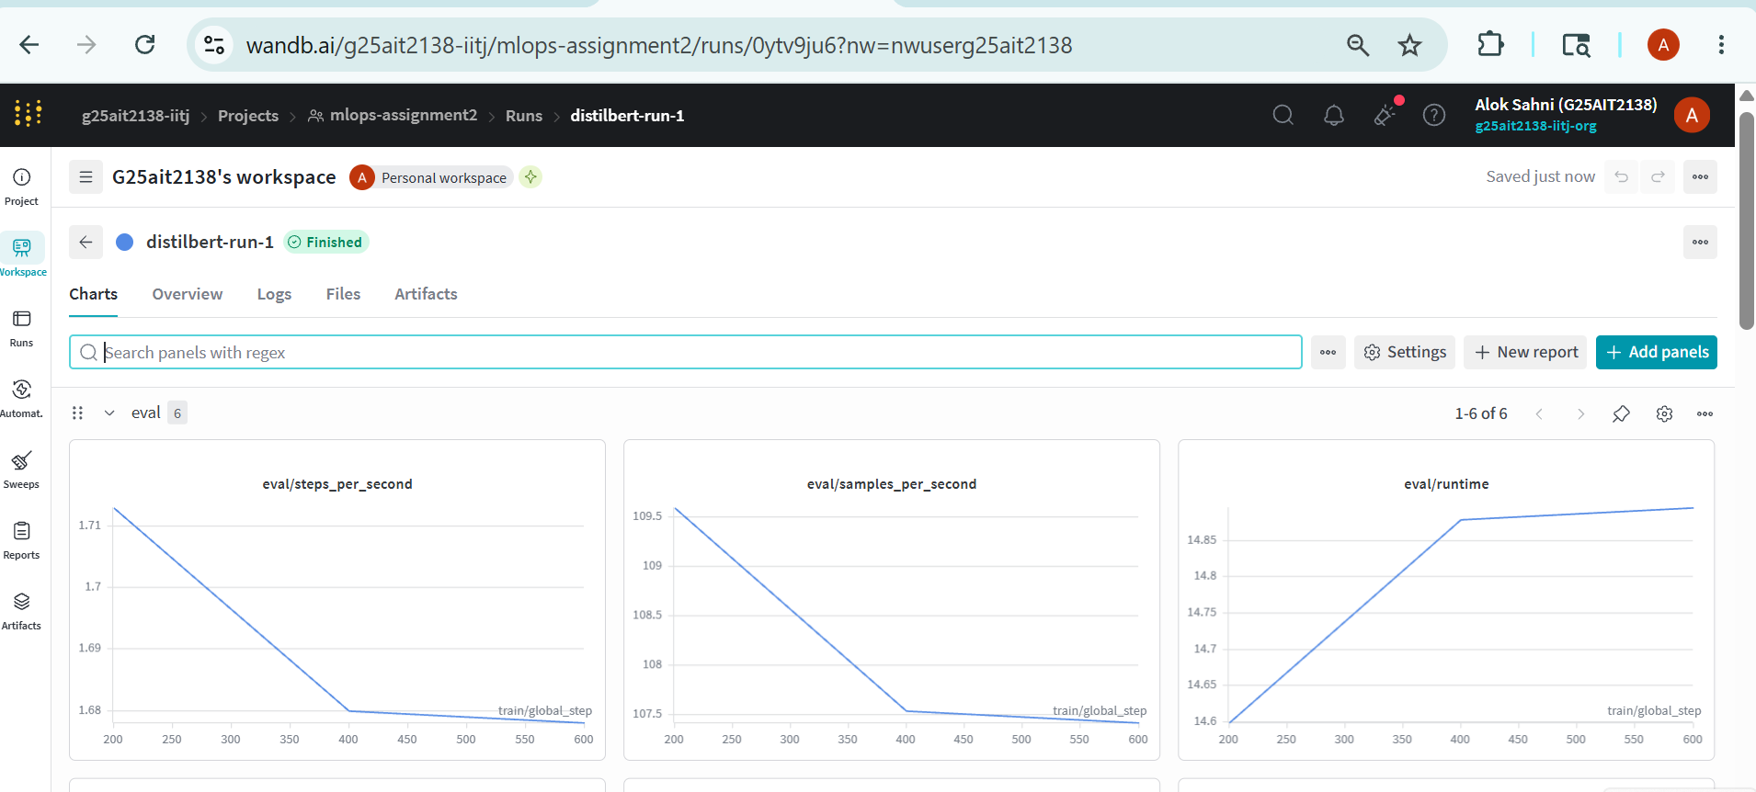
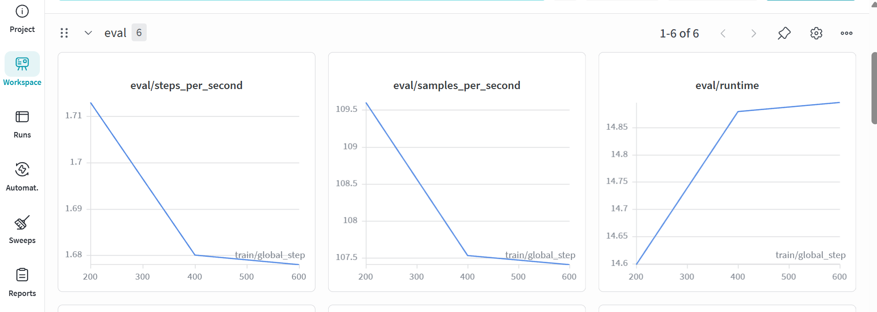
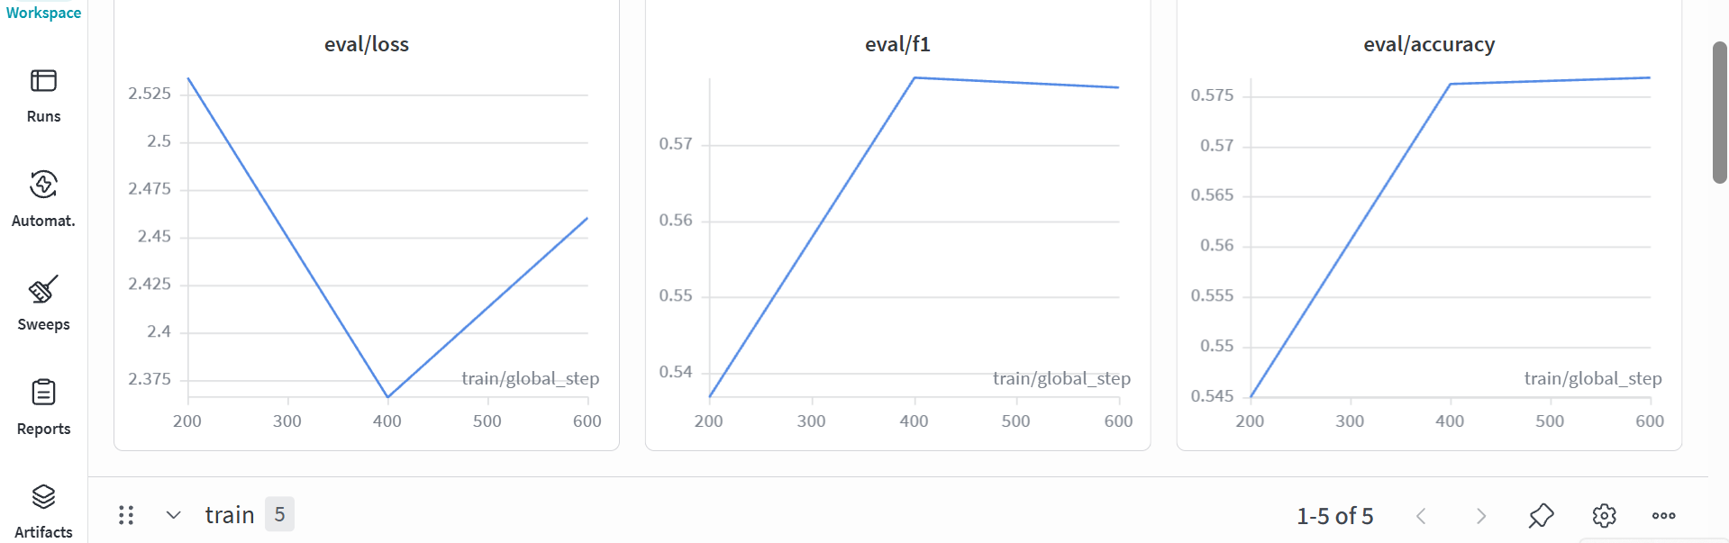
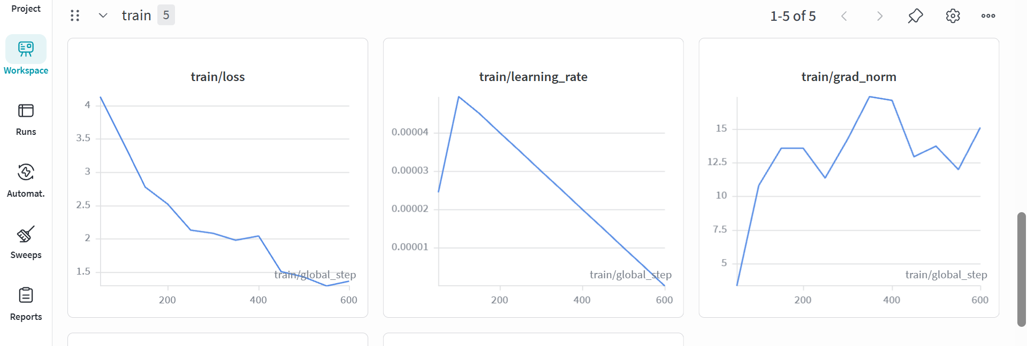
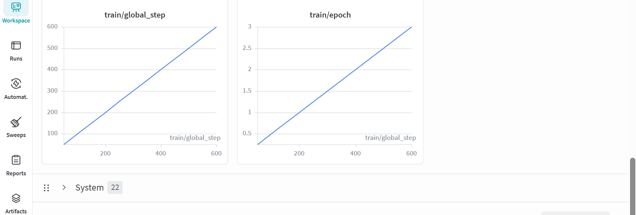

6. Evaluation Results
After training, the best checkpoint was evaluated on the held-out test set (1,600 reviews, balanced 200/genre). The classification report, including per-class precision, recall, and F1, was saved as eval_report.json and uploaded to W&B as a versioned Artifact named eval-report.

Final Test-Set Metrics
Metric | Score
Accuracy | 0.5619
F1 Score (weighted) | 0.5673
Precision (weighted) | 0.5781
Recall (weighted) | 0.5619
Evaluation Loss | 2.8248

Per-Class Classification Report
Genre | Precision | Recall | F1
children | 0.64 | 0.60 | 0.62
comics_graphic | 0.88 | 0.75 | 0.81
fantasy_paranormal | 0.36 | 0.34 | 0.35
history_biography | 0.54 | 0.53 | 0.53
mystery_thriller_crime | 0.55 | 0.59 | 0.57
poetry | 0.71 | 0.76 | 0.73
romance | 0.64 | 0.52 | 0.57
young_adult | 0.31 | 0.41 | 0.35
weighted avg | 0.58 | 0.56 | 0.57

Interpretation. The model significantly outperforms random guessing across eight balanced classes (random baseline = 12.5%). Comics & Graphic (F1 = 0.81) and Poetry (F1 = 0.73) are the strongest classes because their vocabulary is highly distinctive (panel, artwork, stanza, verse). The weakest classes are Young Adult (F1 = 0.35) and Fantasy & Paranormal (F1 = 0.35), which is expected: these genres share heavy thematic overlap with each other and with Romance and Children, so reviews are linguistically ambiguous. A TF-IDF + Logistic Regression baseline scored ~0.53 / 0.53 on the same split, so the fine-tuned transformer delivers a measurable lift on both metrics.

7. Hugging Face Deployment
After training, the model weights and tokenizer were pushed to the public Hugging Face repository ALOK2026/distilbert-goodreads-genres using model.push_to_hub() and tokenizer.push_to_hub(). The HF model URL was also recorded in the W&B run summary so the run and the model are linked. Any user can now load the model with two lines of Python and the AutoTokenizer / AutoModelForSequenceClassification APIs.

8. Challenges and Learnings
- Kaggle Secrets & Internet toggle. The first training attempt failed silently because the Internet switch was off in the Kaggle session, so neither the dataset download nor the W&B / HF authentication calls could reach the network. Toggling Internet on under Notebook → Settings resolved both problems at once.
- GPU memory at max_length=512. With batch_size=16 and max_length=512, the T4 was close to its 16 GB limit. The recommended fallback is to lower the batch size to 8 or the max length to 256 if a CUDA OOM occurs.
- Validation loss rising while accuracy improved. After epoch 1, validation loss began to climb even though accuracy kept inching up. load_best_model_at_end=True with save_strategy="epoch" ensured the lowest-val-loss checkpoint was restored automatically.
- Reproducibility of label IDs. Building the label map with sorted(set(labels)) rather than insertion order is what makes the integer-to-genre mapping stable across runs; without this, the same model file could give different predictions on a re-run.
- MLOps mindset over modelling tweaks. The biggest takeaway was that the workflow around the model — W&B logging, Kaggle Secrets, HF Hub push, modular scripts — gives far more value than chasing the last decimal of accuracy. Two weeks of hyperparameter tuning is dwarfed by a single reproducible artifact that anyone can load from Hugging Face.

What I would do differently next time
- Stratified K-fold cross-validation to get more stable per-class numbers, especially on the weakest classes (Young Adult, Fantasy).
- A short hyperparameter sweep with W&B Sweeps over learning rate (1e-5, 2e-5, 3e-5, 5e-5) and max_length (256 / 512).
- Class-weighted cross-entropy or focal loss to lift Young Adult and Fantasy & Paranormal, which appear to suffer from semantic overlap rather than insufficient training data.
- Log a confusion matrix to W&B alongside the classification report so the off-diagonal confusions (e.g. YA ↔ Fantasy) are visible at a glance.

9. Conclusion
This project delivers a production-oriented MLOps workflow for transformer-based NLP classification. It demonstrates scalable cloud training on Kaggle GPU, live experiment monitoring with W&B, secure secret management via Kaggle Secrets, modular Python scripts, versioned evaluation artifacts, and public deployment to the Hugging Face Hub. DistilBERT proved an excellent choice for the assignment's constraints because it balances speed, memory efficiency, accuracy, and deployment simplicity. The workflow built here is directly transferable to other NLP fine-tuning tasks and forms a solid foundation for future, more advanced MLOps systems such as CI-driven retraining, model monitoring, and automated rollbacks.

All Submission Links
GitHub Repository: https://github.com/g25ait2138-collab/distilbert-goodreads-genres
Kaggle Notebook: https://www.kaggle.com/code/aloksahnig25ait2138/notebook8d09f3f76d/script
Hugging Face Model: https://huggingface.co/ALOK2026/distilbert-goodreads-genres
W&B Dashboard: https://wandb.ai/g25ait2138-iitj/mlops-assignment2/workspace?nw=nwuserg25ait2138

